NET731 – Cloud Networking
Week 8 Practical: Cost Management
24 – 30 April 2026 | Total Marks: 8
Student Name: _Rayner Marsh_________________ Student No: 20240179__________________

Overview
This practical focuses on managing and monitoring the costs of your Azure environment. You will configure budget alerts, analyse your resource consumption, and document your cost management strategy using GitHub. The goal is to keep your spending within a $100 limit while maintaining a functional cloud environment.

Work through each task carefully. Read the instructions fully before starting. Where hints are provided, use them as a starting point for your own investigation — do not simply copy an answer.

Task 1: Create Azure Budget Alerts
Azure Cost Management allows you to set budgets and configure alerts so you are notified before you exceed your spending threshold. In this task, you will create a budget and link it to alert notifications.

Steps to follow:
- Log in to the Azure Portal and navigate to the Cost Management + Billing section.
- Locate the Budgets option and create a new budget scoped to your subscription.
- Set an appropriate budget amount and time period based on your $100 limit.
- Configure at least two alert conditions — consider what thresholds make sense (e.g. 80% and 100%).
- Add your student email as an alert recipient.
- Save the budget and take a screenshot showing the completed budget configuration.

Hint: Think about what percentage thresholds would give you enough warning before you run out of budget. Consider the difference between actual spend and forecasted spend alerts.

Evidence required: A screenshot of the configured budget showing the name, scope, amount, and alert conditions.
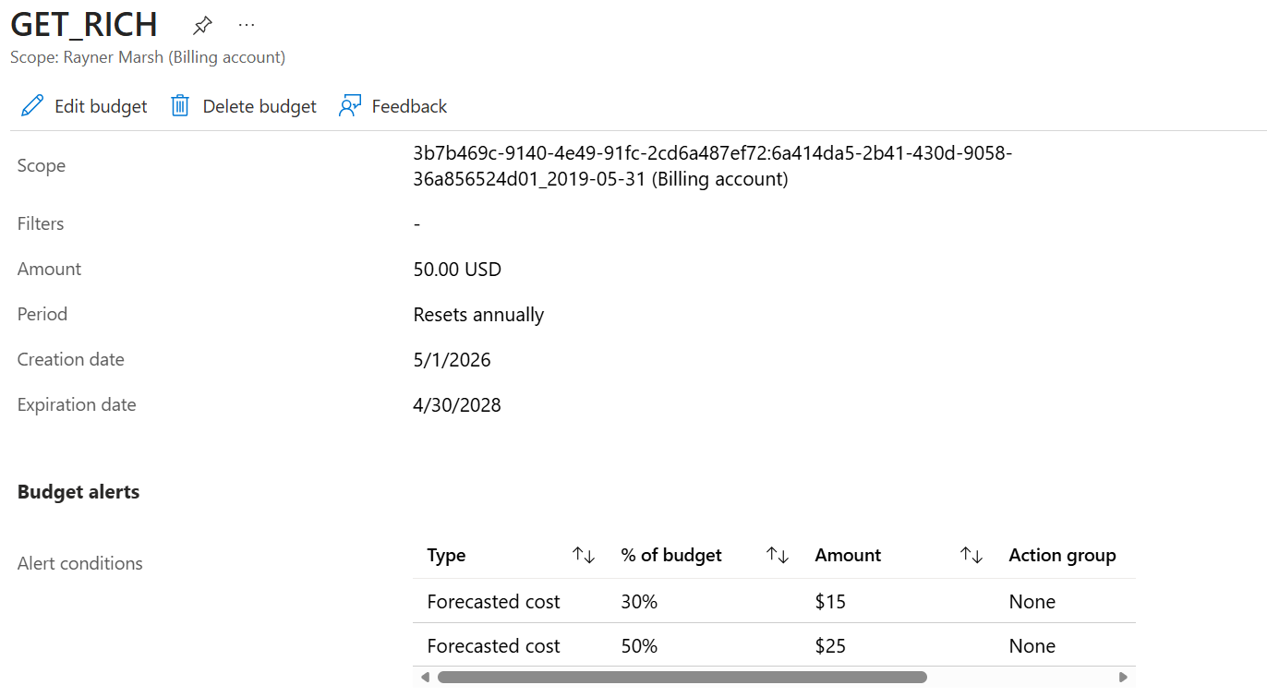


Task 2: Monitor Usage and Adjust Resource Settings
Once your budget is in place, you need to actively monitor your resource usage and make informed decisions about how to control costs. This task requires you to analyse your current spend and adjust at least one resource setting to reduce or optimise cost.

Steps to follow:
- In Cost Management, open the Cost Analysis view for your subscription.
- Review your spending by resource type, resource group, and service.
- Identify your highest-cost resource(s) and investigate why they are costing the most.
- Make at least one adjustment to reduce or control cost — this could include resizing a VM, stopping an unused resource, or modifying a service tier.
- Take a before-and-after screenshot or note of the change made.
- Estimate your projected monthly spend based on your current usage pattern.

Hint: Look at the resource breakdown in Cost Analysis. Which resource type is consuming the most budget? Can it be stopped when not in use, or downsized? Think about the difference between deallocating and deleting a VM.

Evidence required: Screenshots of the Cost Analysis view and documentation of the changes you made, with a brief explanation of why you made them.
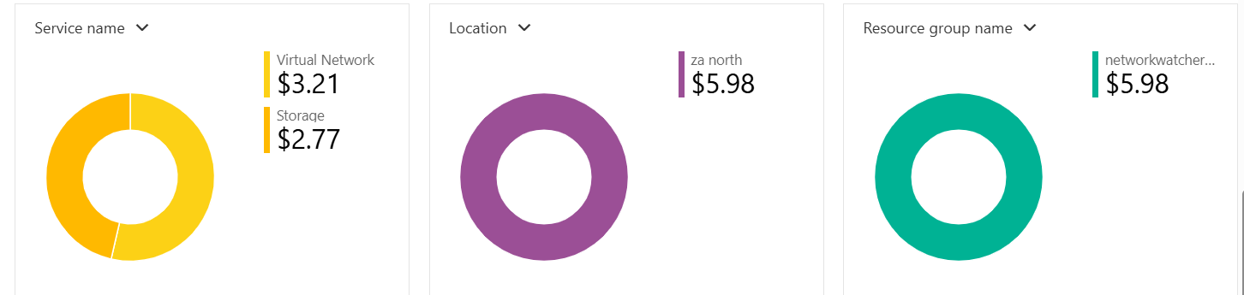

Task 3: Document Cost Management Process in GitHub
Good cloud governance includes maintaining clear documentation of your cost management decisions. You will create a cost management report and commit it to your GitHub repository.

Documentation should include:
- A summary of your budget configuration (budget name, scope, amount, alert thresholds).
- A breakdown of your top 3 most expensive resources and why they cost what they do.
- The change(s) you made in Task 2 and the expected cost impact.
- Your projected total spend for the project period and whether you are on track to stay within $100.
- Any recommendations you would make to a future student to manage Azure costs effectively.

GitHub submission steps:
- Create a new file in your repository: cost-management/cost-report.md
- Write your documentation in Markdown format.
- Include your screenshots as images in the repository (in a screenshots/ subfolder).
- Commit and push with a meaningful commit message.

Hint: A good Markdown report uses headings, bullet points, and inline images. Refer to your GitHub from earlier weeks if you need a reminder on how to commit files. Make sure your commit message describes what you have done, not just 'update'.

Reflection Questions
Answer the following questions in your cost-report.md file (2–3 sentences each):

- What surprised you most about your Azure spending this week?
I was surprised that Virtual Network accounted for $3.21 of the $5.98 total spend, more than Storage. It showed me how quickly network monitoring features like Network Watcher can add up even in a small test environment.
- How would cost management differ if this were a production environment used by a real business?
In production, costs would be higher and spread across multiple teams, regions, and services, so tagging and budgets would be critical for accountability. I’d also need automated alerts and regular reviews to catch cost spikes before they impact the business.
- What additional Azure Cost Management features would you explore if you had more time?
I’d explore setting up budgets with automated alerts, using cost anomaly detection, and running Azure Advisor recommendations for rightsizing. I’d also try exporting data to Power BI to build custom dashboards for deeper analysis.

Marking Rubric – Week 8 (8 Marks)

Criterion | Marks | What to demonstrate
Budget alert configured correctly | 3 | Budget exists with correct scope, amount, and at least two alert thresholds. Screenshot provided.
Cost analysis and resource adjustment | 3 | Evidence of reviewing Cost Analysis, identifying expensive resources, and making at least one informed adjustment.
GitHub documentation | 2 | cost-report.md committed to repository with all required sections, screenshots included, and meaningful commit message.

Submission Checklist
- Budget configured in Azure with screenshots saved
- Cost analysis reviewed and at least one resource adjusted
- cost-report.md created and committed to GitHub
- Screenshots uploaded to repository screenshots/ folder
- Reflection questions answered in cost-report.md

Due: End of Week 8 (30 April 2026). Ensure your GitHub repository is up to date before the deadline.

